ДНЗ «Уманський професійний аграрний ліцей»

ВІДКРИТИЙ УРОК
З АНГЛІЙСЬКОЇ МОВИ
на тему:
«Англомовні країни: загальні відомості»

Вальчевська О.В.
викладач іноземної мови

Умань, 2015

Мета: сформувати більш повне уявлення учнів про англомовні країни, а зокрема Канаду; поглибити та розширити знання про вже відомі факти, тренувати учнів в читанні, письмі, говорінні; розвивати пам`ять та логіку, розумові та речові здібності учнів.
Тип уроку: комбінований урок
Методи проведення уроку: словесні, наочні, практичні
КМЗ: карта, роздатковий матеріал, картки.
Міжпредметні зв'язки: географія.

PROCEDURE
I. INTRODUCTION.
T: Good morning. Nice to see you. We continue to learn about English speaking countries. We’ve discovered something about Great Britain and the USA. Can you guess what country we are going to speak about today?
Expected answer:
S: About Canada.
T: Right you are. At this lesson we’ll try to make a report in geography of Canada. This lesson is unusual because you’ll get knowledge yourselves using different sources of information.

II. PHONETIC DRILLS.
Look, listen, learn!
T: Let it be the motto of our lesson.

III. MAIN PART.
1. GROUP WORK.
T: We’ll start with revising our knowledge of English speaking countries. What plan do we use to do the geographical outlook of the country?
Students do the tasks 1-4.
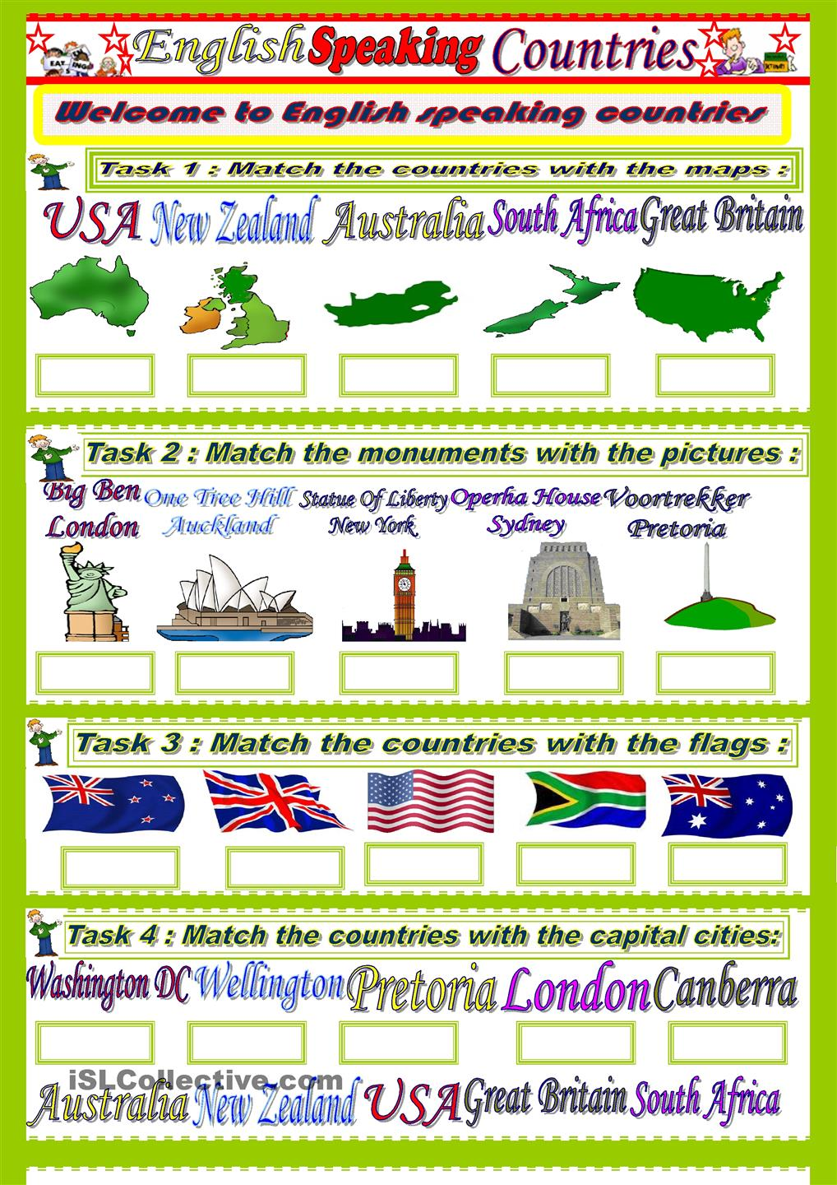
2. VOCABULARY REVISION.
T: I’d recommend you to review some geographical terms and word-combinations.
Unscramble words.

to derbor on
to be edshwa by
an eara
a lowndla
a tainmoun ragen
a aticclim nezo
ctiarc
ticsubarc
petemrate

Key: to border on, to be washed by, an area, a lowland, a mountain range, a climatic zone, arctic, subarctic, temperate.

3. INTRODUCTING NEW VOCABULARY.
T: Let’s work with some proper names. Listen and repeat.
Canada the Mackenzie
North America Nelson
The Pacific ocean Yukon
The Atlantic ocean Rocky mountains
The Arctic ocean Great Lakes
Ottawa Great Bear Lake
Toronto Niagara Falls
The first group will search for information about geographical position and the surface, another one will work with points “Climate” and “Lakes and rivers”. Then you’ll share the results of your research. The only available source of information for each group is a map of Canada.

5. READING.
Pre-reading activity.
T: Look at the text and say what information you are going to find in it.
Possible answer:
S: We are going to learn more about population, language, cities and economy of Canada.
Reading.
T: Read the text and find necessary information to complete your chart.
Canada.

Canada is a country in North America. It has three territories, Northwest, Yukon and Nunavut. It also has ten provinces including: Ontario, Quebec, Nova Scotia, New Brunswick, Manitoba, British Columbia, Prince Edward Island, Saskatchewan, Alberta, and Newfoundland. It is the second largest country in the world by total area and has the longest common border in the world – the border between Canada and the United States. It has a population of 27 million on an area of 9,976,185 square kilometers! Most of the population is descended from European immigrants. Only 1.5% of today's population is descended from the original Eskimo and Indian inhabitants.
Britain and France fought over Canada for nearly two hundred years. Finally in 1763 Britain took control. Canada is now an independent country with its own prime minister, but the head of state is still the British Queen.
Canada is a bilingual country. The majority of the population speaks English. Most French speakers live in the province of Quebec. Canada's largest city is Toronto. It has a population of 3,800,000. But Toronto is not the capital city. The capital is Ottawa in the province of Ontario.
The national emblem of Canada is the maple leaf and the currency is the Canadian dollar. Canada is a huge country. Its longest river, the Mackenzie, flows for 1,600 km into the Arctic Ocean. It is also a very rich country. It has many' industries (cars, electrical goods, etc.). It produces almost every mineral (gold, silver, iron, copper, uranium, oil, coal, etc.). Canada is the world's biggest producer of nickel, the second biggest producer of zinc and the third biggest producer of lead. Canada is also one of the world's biggest producers of wood and paper (44% of the land is forest). Agriculture (mostly wheat and cattle) is important, too.

Post-reading activity.
T: Do we have a result? Prove it. Tell what you know about Canada. Use your chart and a contour map.

6. PAIR WORK.
T: My congratulations! You are real experts in geography of Canada. Besides you know how to get information using different sources of it.
Your classmate got a task to make a report about geographical position of the USA. He needs information. Give him advice how to find it. Use the following models:
- You should …
- Why don’t you …?
- Let’s …
- What about …?

IV. SUMMING-UP.
T: Let’s make a conclusion. What have you learnt to do at the lesson?
Now I Can …
read and listen about the geography in English.
search for information in different sources.
do a geographical outlook of Canada using a map and a chart.
use the Present Perfect Tense in Passive Voice

V. HOME ASSIGNMENT.
Your Geography teacher would like you to help her in preparing for the lesson on the topic “Canada”. So your home task will be to make a geographic quiz “What Do You Know about Canada?”
Your marks are … Thanks a lot. The lesson is over. Good bye. Have a nice day.

References:
- http://ru.wikipedia.org.
- http://uchenik-ok.narod.ru
- http://lonelyplanet.com/maps

